EXECUTION SCREENSHOTS

DDL EXECUTION DATABASE :
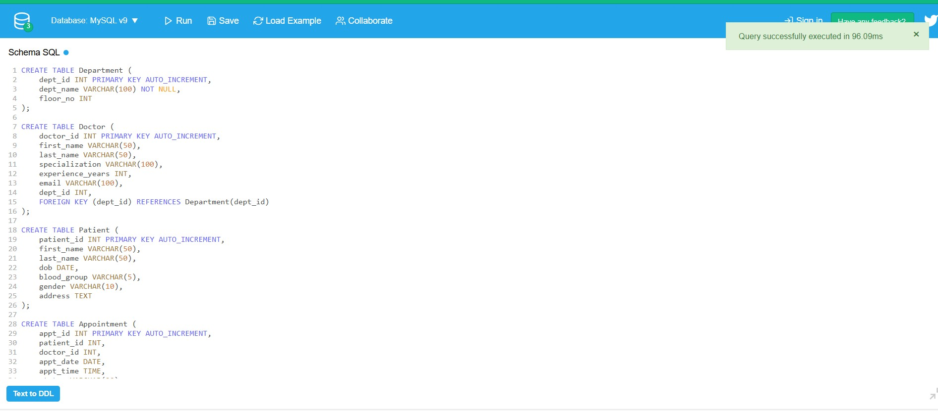

DML QUERIES EXECUTION :
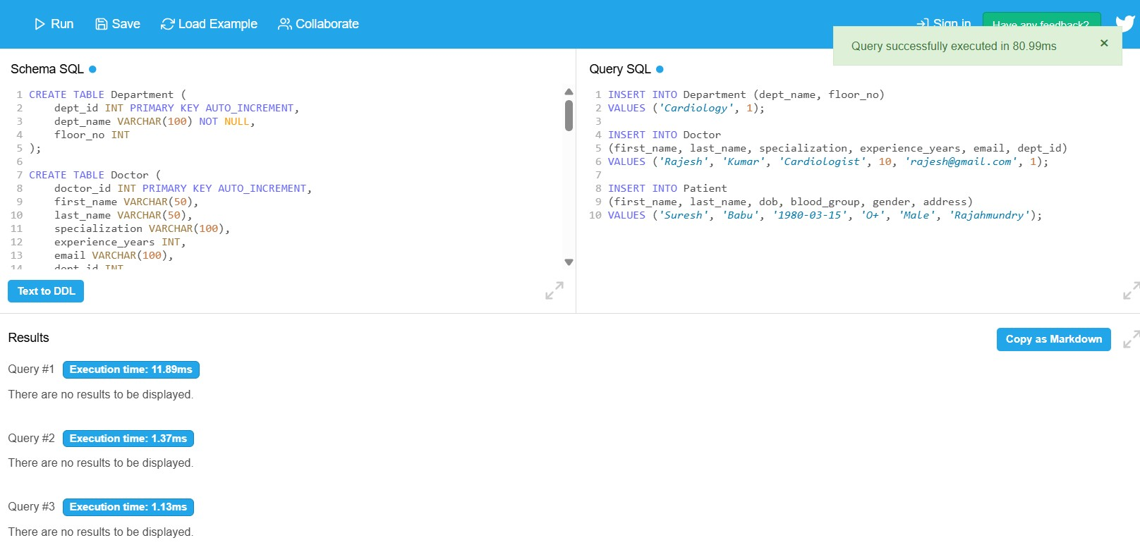
CRUD OPERATIONS :
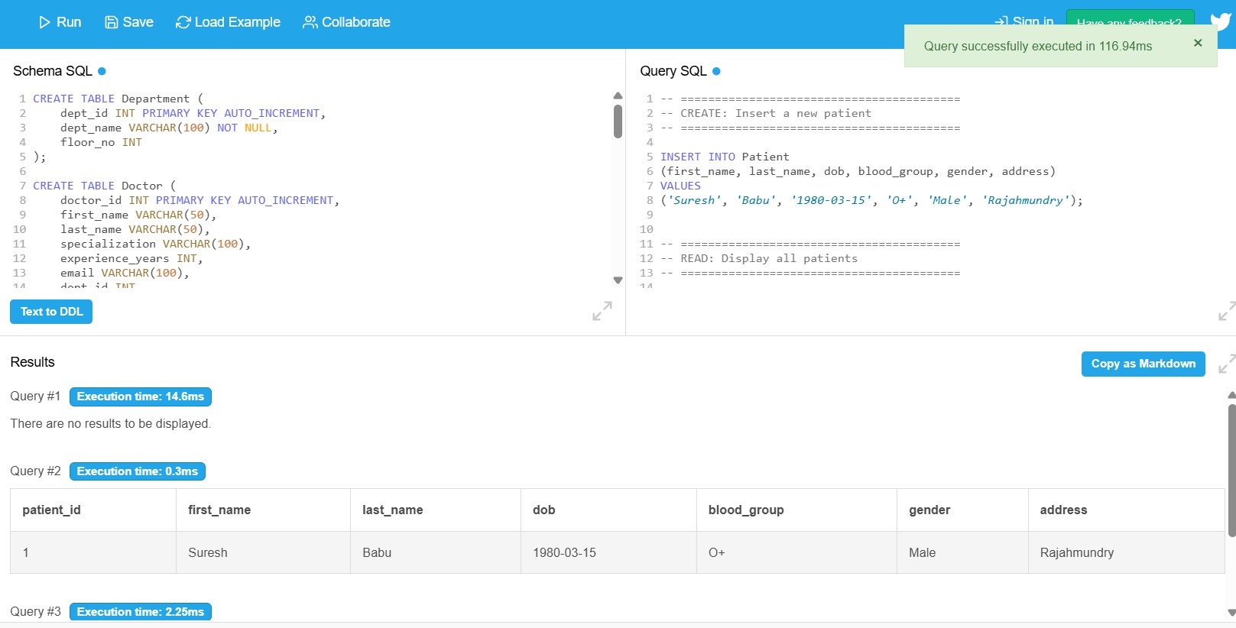

OTHER SQL QUERIES :
